Infosys Springboard Virtual Internship 6.0 Completion Report

Team Details
Batch Number : 13
Start date : 02-FEB-2026
Names:
- HARISH RAGAVENDRAN V
- YOGANANDHA BANAVATHU
- MARY KUMARI T
- PRAJIT V
- HIRANMAYI MULA
- VIGNESH N
- VIJAYALATHA P
- ADITHYA ARUN
- VARSHITHA SRI KOTAPROLU
Internship Duration: 8 Weeks

1. Project Title : FoodTrends Understanding Customer Preferences in FB

2. Project Objective

FoodTrends is a data analytics project developed using Power BI to analyze food consumption, nutrition, and lifestyle patterns. It aims to understand how dietary preferences vary across demographics and how nutrition impacts health. The project provides data-driven insights to support healthier lifestyle decisions.

3. Project description in detail

This project analyzes food-related datasets collected from web-based sources. Data preprocessing and analysis were performed to understand dietary patterns, nutritional intake, and customer preferences. Tools like Python and Power BI were used for analysis and visualization. The project provides insights that help improve food recommendations and business strategies.

4. Timeline Overview

Week | Activities Planned | Activities Completed
Week 1 | Planning, Data Collection | Defined objectives, Collected data
Week 2 | Data Cleaning, Data Analysis | Cleaned and processed data
Week 3 | Data Analysis, Visualization | Performed analysis, Created charts
Week 4 | Dashboard Development | Built Power BI dashboards
Week 5 | Dashboard Finalization | Finalized dashboard
Week 6 | PPT Preparation | Prepared PPT
Week 7 | Testing and Validation | Tested and verified results
Week 8 | Final Report and Presentation | Completed report, Presented project

5a. Key Milestones

Milestone | Description | Date Achieved
Project Kickoff | Project initiation and planning | Week 1
Prototype/First Draft | Initial analysis and dashboard | Week 4
Mid-Term Review | Progress evaluation and improvements | Week 6
Final Submission | Completed project and report | Week 7
Presentation | Final project presentation | Week 8

5b. Project execution details

The project was executed by defining clear objectives, collecting web-based datasets, and performing data cleaning and preprocessing to ensure accuracy. Exploratory data analysis was conducted to identify patterns in food consumption, nutrition, and lifestyle, followed by creating interactive Power BI dashboards for visualization. Key metrics such as calorie intake, macronutrients, and activity levels were analyzed to generate meaningful insights, which were then validated, compiled into a report, and presented effectively.

6. Snapshots / Screenshots

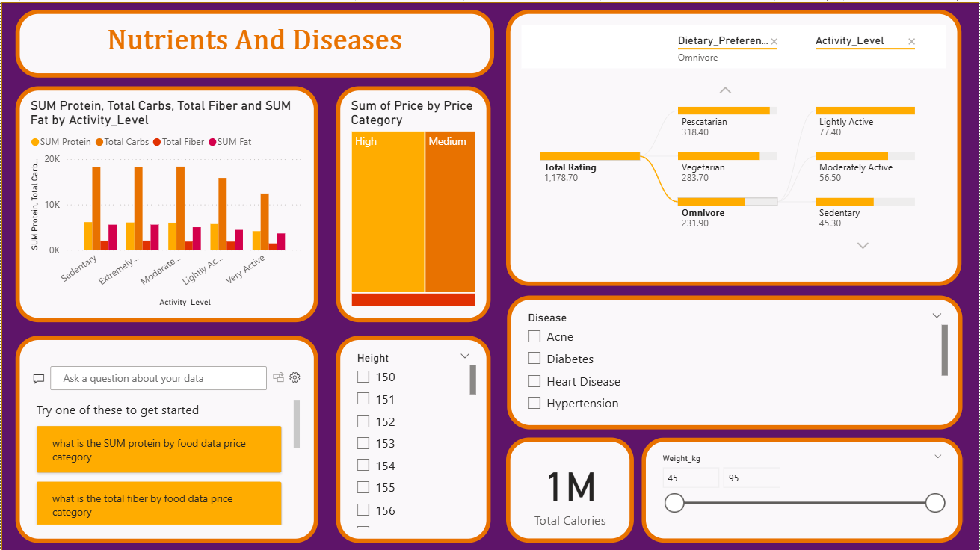
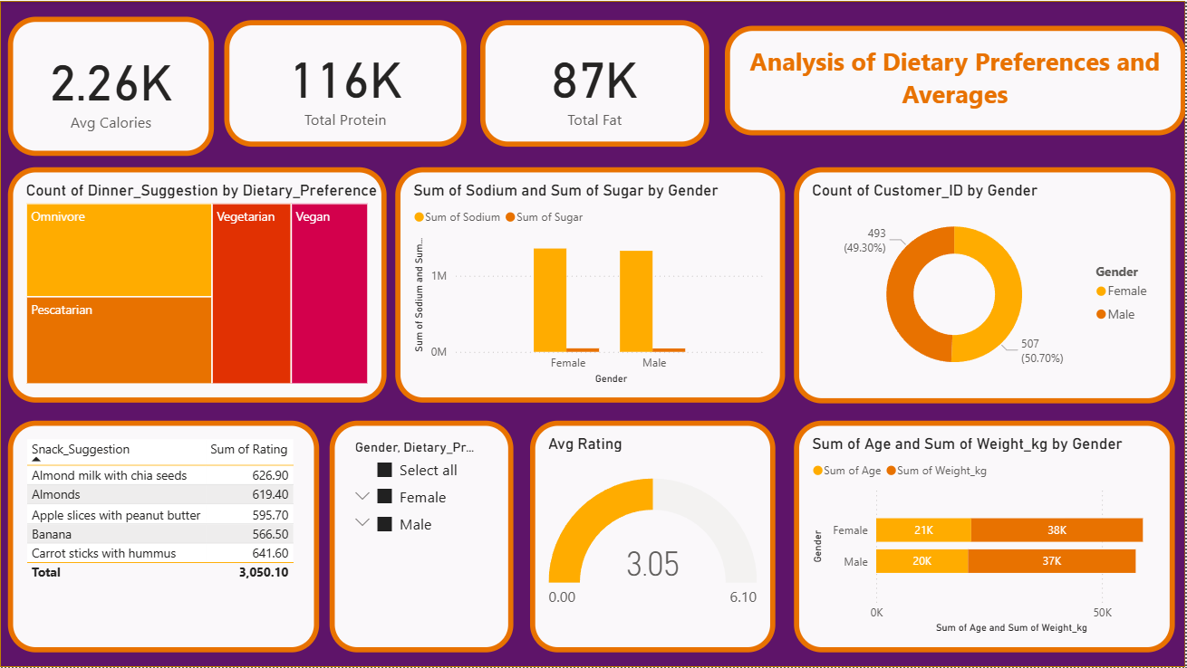

7. Challenges Faced

Challenges included handling missing and inconsistent data, creating effective visualizations, and identifying meaningful patterns. These were resolved through data preprocessing, iterative dashboard design, and exploratory data analysis.

8. Learnings & Skills Acquired

Gained hands-on experience in data analysis, data preprocessing, and visualization using Power BI. Developed skills in interpreting datasets, generating insights, and understanding food and nutrition patterns. Improved problem-solving, analytical thinking, and teamwork skills.

9. Testimonials from team

The project was a valuable learning experience that enhanced our data analysis and visualization skills. It helped us understand real-world problem solving and improved our teamwork and collaboration. Successfully completing the project and generating meaningful insights was a key achievement.

10. Conclusion

The internship provided valuable hands-on experience in data analytics and visualization, enhancing both technical and analytical skills. The project successfully delivered meaningful insights and strengthened understanding of real-world data applications. It aligns well with my academic background and supports my goal of building a career in data analytics.

11. Acknowledgements

I sincerely thank Infosys Springboard for providing this valuable internship opportunity. I am grateful to my mentor for their guidance and support throughout the project. I also appreciate my team members for their collaboration and contribution to successfully completing the project.

